Mockito Exercises
Name: M. Sai Teja Email: saitejamuddapati@gmail.com
Exercise 1: Mocking and Stubbing
Scenario
You need to test a service that depends on an external API. Use Mockito to mock the external API and stub its methods.
Steps
1. Create a mock object for the external API.
2. Stub the methods to return predefined values.
3. Write a test case that uses the mock object.
Java Code
pom.xml (Maven Dependencies)
<dependency>
<groupId>org.mockito</groupId>
<artifactId>mockito-core</artifactId>
<version>5.11.0</version>
<scope>test</scope>
</dependency>
<dependency>
<groupId>org.junit.jupiter</groupId>
<artifactId>junit-jupiter</artifactId>
<version>5.10.2</version>
<scope>test</scope>
</dependency>

ExternalApi.java
package com.example;

public interface ExternalApi {
String getData();
}

MyService.java
package com.example;

public class MyService {

private final ExternalApi externalApi;

public MyService(ExternalApi externalApi) {
this.externalApi = externalApi;
}

public String fetchData() {
return externalApi.getData();
}
}

MyServiceTest.java — Mocking & Stubbing
package com.example;

import static org.junit.jupiter.api.Assertions.assertEquals;
import static org.mockito.Mockito.*;
import org.junit.jupiter.api.Test;
import org.mockito.Mockito;

public class MyServiceTest {

@Test
public void testExternalApi() {
ExternalApi mockApi = Mockito.mock(ExternalApi.class);
when(mockApi.getData()).thenReturn("Mock Data");
MyService service = new MyService(mockApi);
String result = service.fetchData();
assertEquals("Mock Data", result);
}
}

Output
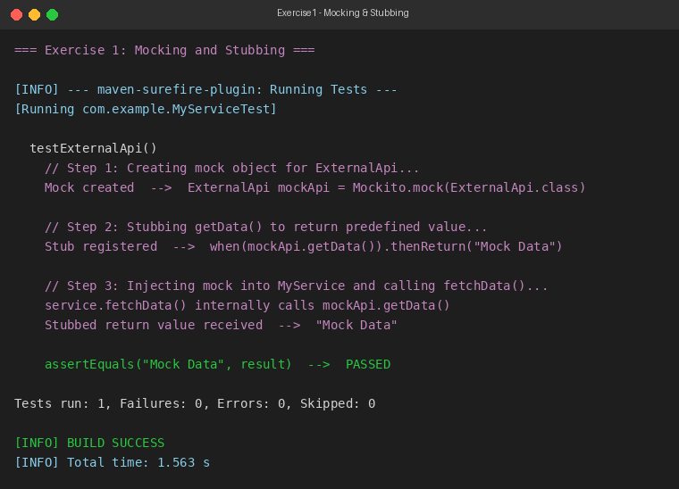
Exercise 2: Verifying Interactions
Scenario
You need to ensure that a method is called with specific arguments.
Steps
1. Create a mock object.
2. Call the method with specific arguments.
3. Verify the interaction.
Java Code
MyServiceTest.java — Verifying Interactions
package com.example;

import static org.mockito.Mockito.*;
import org.junit.jupiter.api.Test;
import org.mockito.Mockito;

public class MyServiceTest {

@Test
public void testVerifyInteraction() {
ExternalApi mockApi = Mockito.mock(ExternalApi.class);
MyService service = new MyService(mockApi);
service.fetchData();
verify(mockApi).getData();
}
}

Output
